Good and bad design practices of similar web user interfaces

Tomasz Garyga

# [www.cinema-city.pl](http://www.cinema-city.pl)

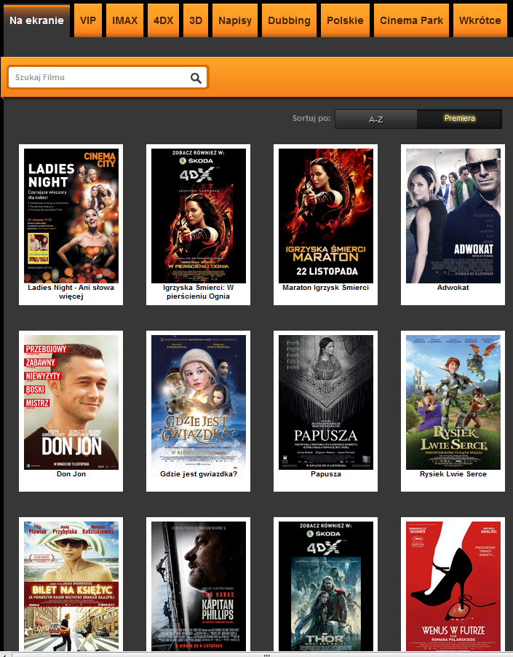

Figure 1

This website is example of Polish cinema website where user can check what is played and also can book or buy a tickets to the cinema.

First of all there can be recognized some interesting (and IMO good) features. Every movie is shown as picture of the movie poster with label below. This type of exposition is clear and easy to understand. Second good things is fact that above the tabs are available. Using this tabs, user can choose if want see all movies or only some types of movies (e.g. only 3D, only Polish movies, movies with dubbing, etc.).

On this website user also can search movies using search tool. Good thing connected with this search tool is fact that it gives some tips when user start write (figure 2). User can choose which order he prefers: alphabetic or newest as the first.

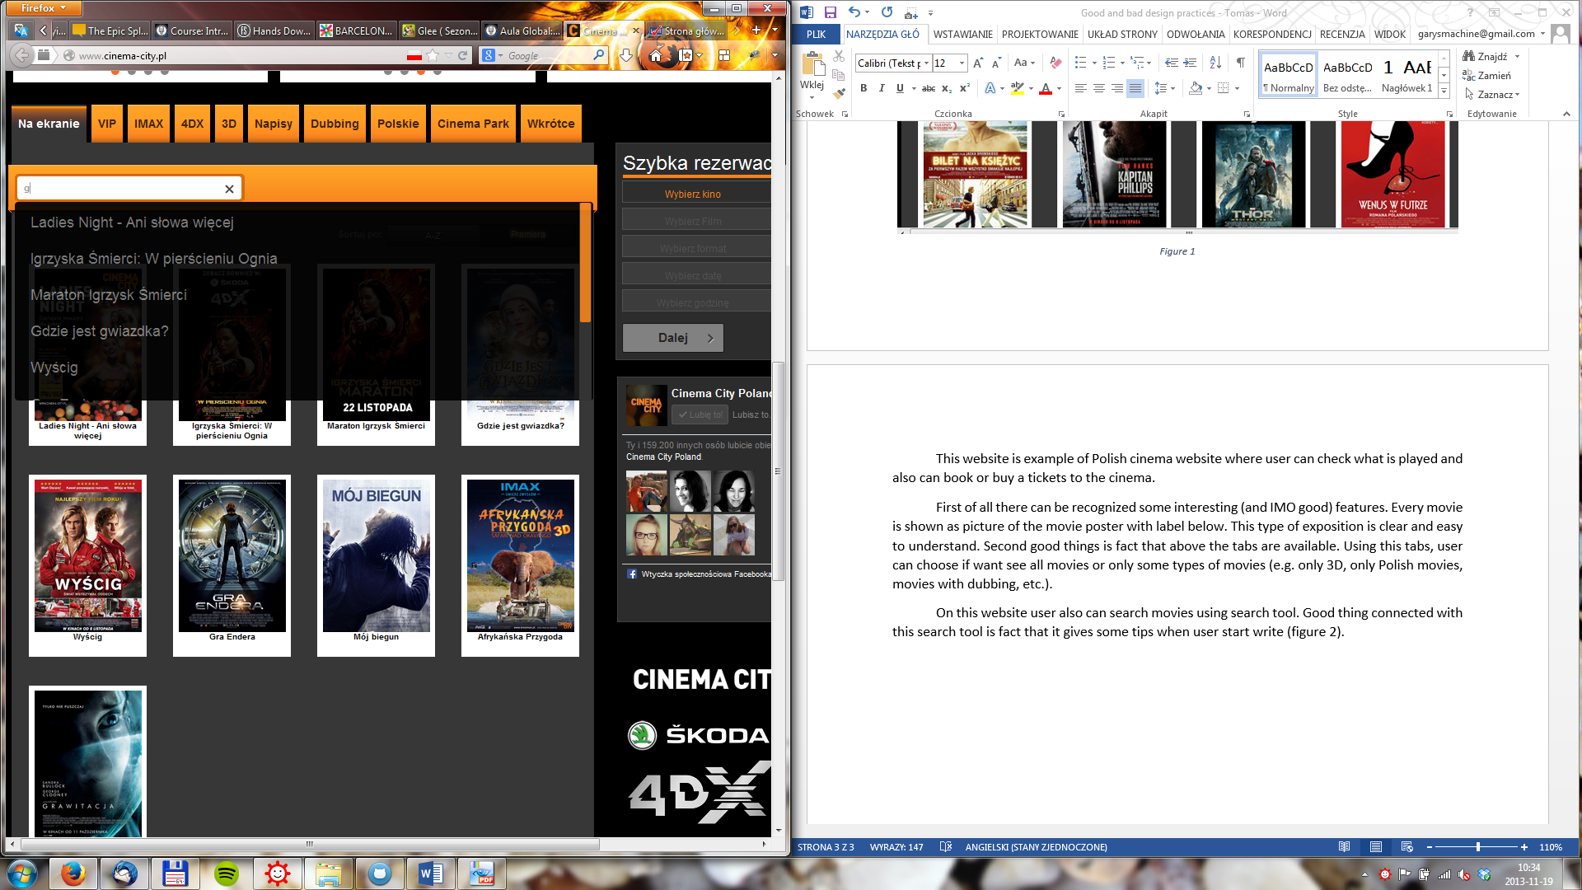

Figure 2

When user choose movie, the additional screen is shown (figure 3). On this site the basic information about movie are available, like title, type, director etc. Also the description of the movie is shown. Normally user can click on the poster of the movie. This action obtain play the trailer of the movie in the same screen (figure 4). The first **bad thing** is recognized here. When trailer is played the bottom “return” isn’t visible enough because movie window covers it.

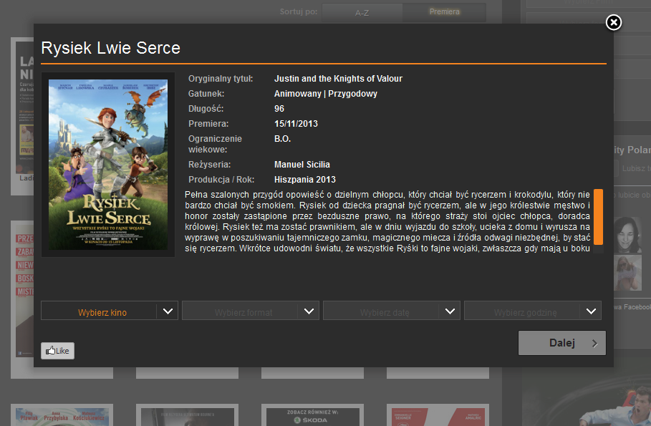

Figure 3

On the screen with description of movie (figure 3) user has simply form which can use when want to buy a ticket. There is observed next **bad practice**. The user isn’t informed that he can use this form to buy tickets.

In this form user firstly can choose the cinema (this website is only about one cinema company so it doesn’t have all cinemas in some area). After, user can choose what type of movie he want to see (if any types are available, e.g. 2D, 3D, dubbing, subtitles). After he choose date and hour.

When user fill form he can decided if he want to only book or buy tickets. After choose one of this options user needs to accept conditions and rules of the cinema. One of the last steps is choose how many (and what type: for adults, children, students) tickets user want to buys/books and numbers of the sits (figure 5).

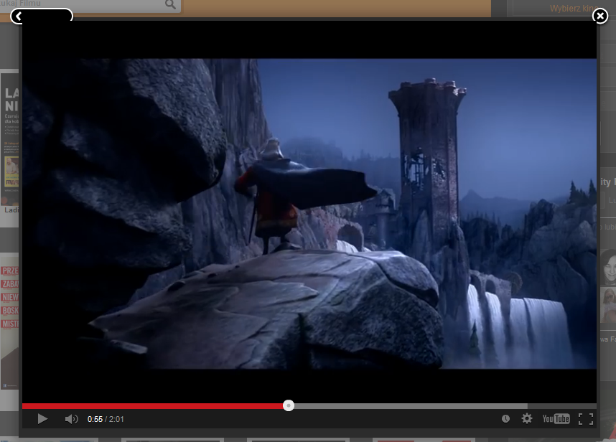

Figure 4

When user finished all steps he need only fill the form about his personal data (name, surname, email address and phone number).

Whole process is very linear and user shouldn’t have any problems with forms and this process.

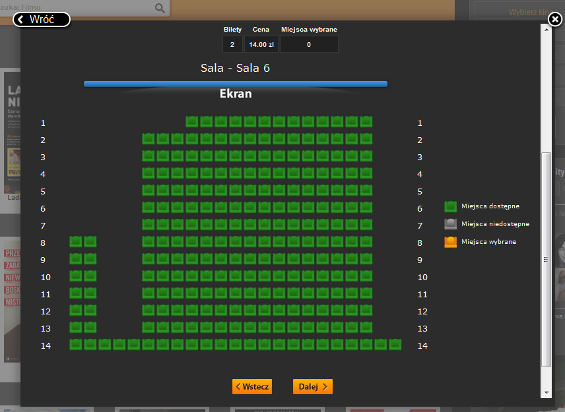

Figure 5

# [www.helios.pl](http://www.helios.pl)

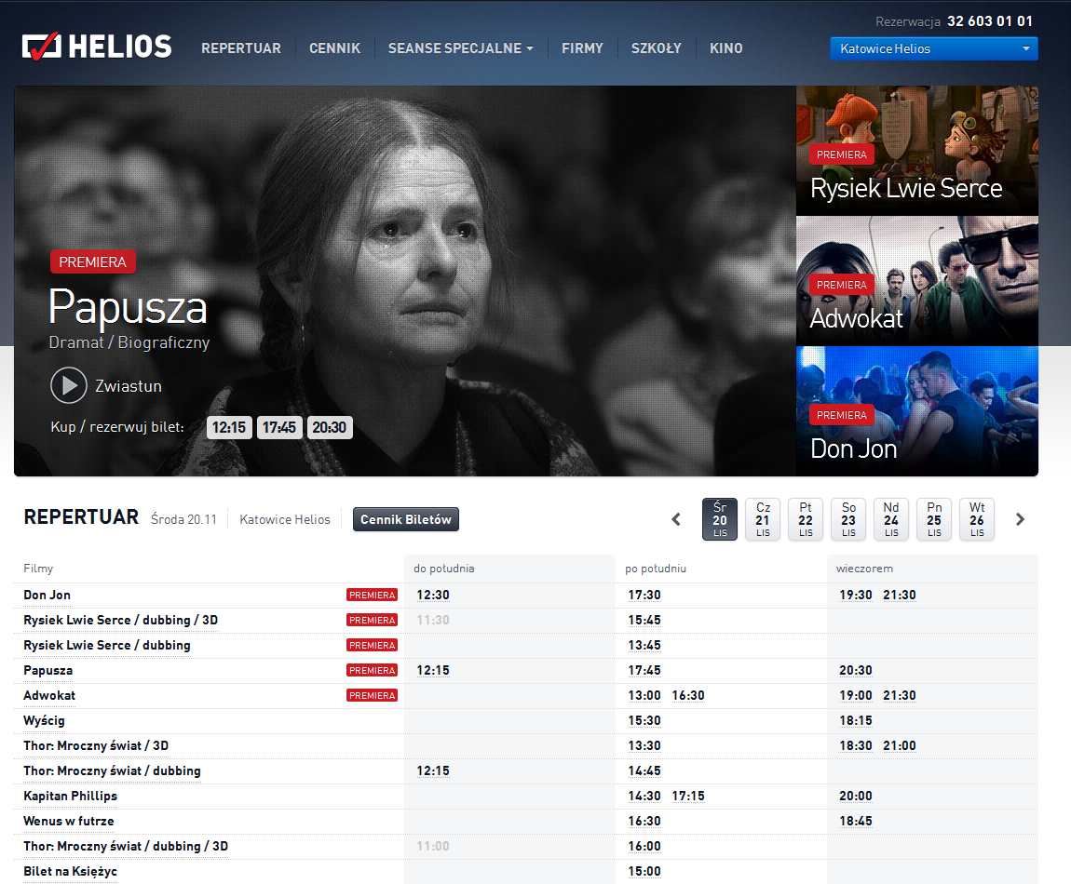

Figure

This is next website of polish cinema company. The homepage (figure 6) shows repertoire of one cinema (in this case cinema in Katowice City – this option was remembered after last session). The cinema can be changed in every moment in the right top corner.

The first part of the homepage are adverts of newest movies. User can click on one of this adverts and read description of the movie. Below this adverts user can find full list of movies played in this cinema. On the top part of this section user can choose the date and also can open the site when can check prices of the movies (“ceny biletów”).

When user decides which cinema and date he can choose one of the movies from the list. User has two options now. He can click on the name of the movie or on the selected date. If he clicks on the date he will be situated on the book/buy screen. If user chooses name of the movie the website with description of movie will be shown (figure 7).

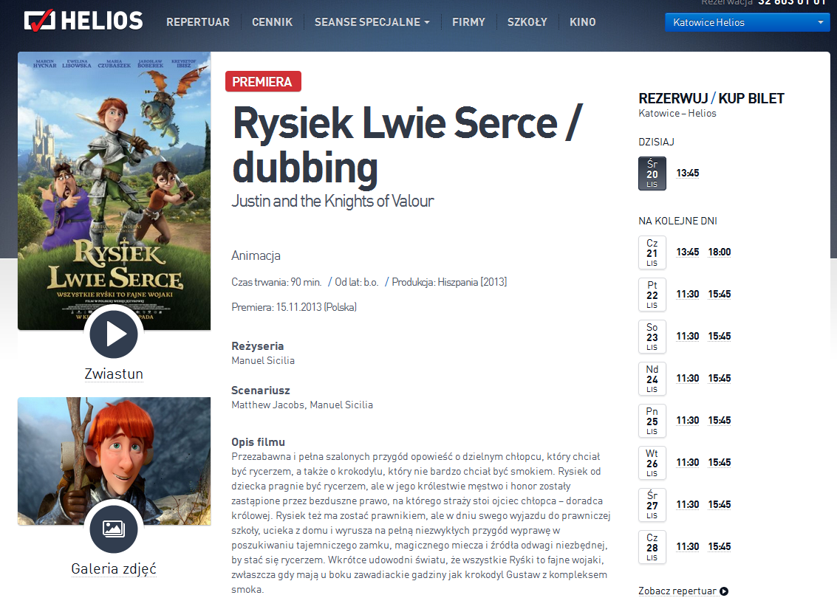

Figure

From this site (figure 7) user can open trailer or photo gallery of selected movie. Both of are opened in new windows, easy to close and return to description of movie. On the right side user can choose the day and time of the movie. When he do it new window are shown (figure 8). On this window user can choose if he want to book or buy tickets on this showing. After making a choice the screen with cinema room is shown (figure 9). User can choose how many and which places want to book/buy.

When user choose the places he is asked to accept the choice. The last step is fill the form with personal data (name, surname, email address and phone number).

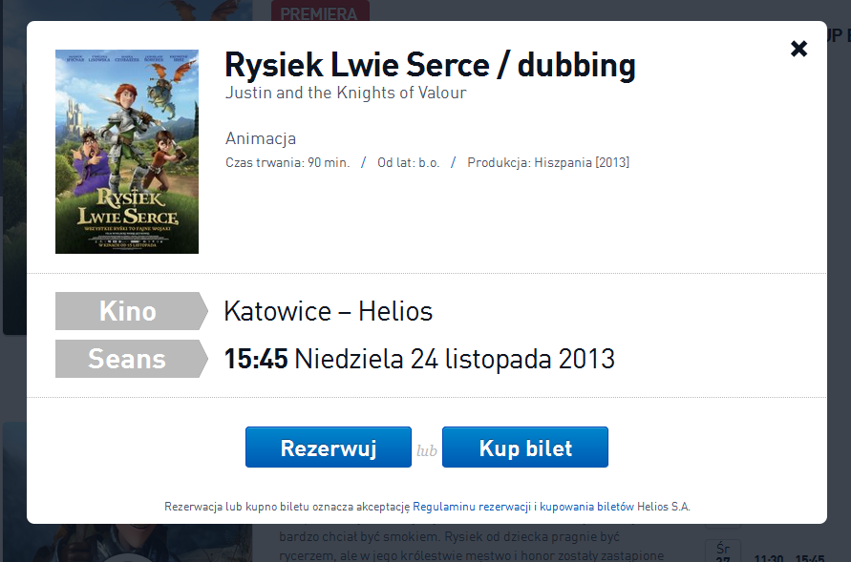

Figure

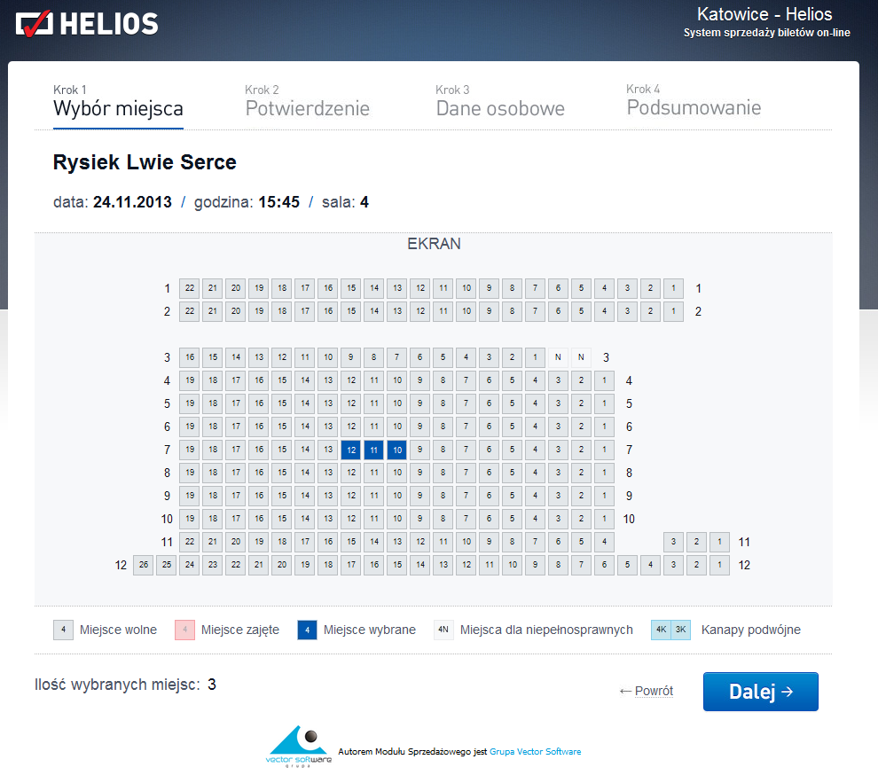

Figure